Independent Practice:

- How many cells does meiosis make?

- How much DNA is in each cell after meiosis?
  - ¼
  - ½
  - 1
  - 1 1/2

- Fill the blanks for each of these cells:

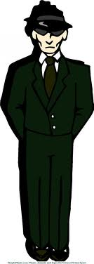
Man Tree Dandelion
(Ponderosa Pine)
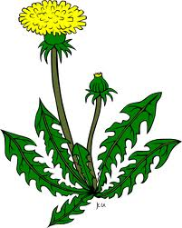
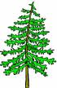

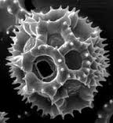

Body cell: 46 chromosomes Body cell: Body cell: 16 chromosomes
Sex cell: Sex cell: 13 chromosomes Sex cells (Pollen):

Dog Buffalo Fruit fly
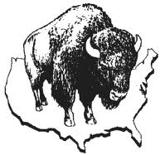
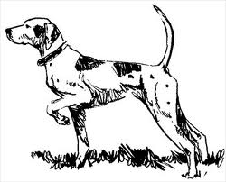
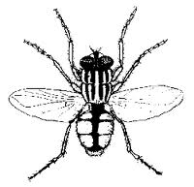

Body cell: Body cell: 60 chromosomes Body cell: 8 chromosomes
Sex cell: 39 chromosomes Sex cell: Sex cells:

Define:
Haploid:
Diploid:

Turn over!!

Copy the picture of Meiosis 1 and label the phases and give a brief description of each phase.

