Name: ________________KEY_________________________ Date: __________________ Period: _________________

Unit 5: Cellular Reproduction-Lesson 3
Mitosis Vocabulary

Vocabulary Term | Definition
Chromatin | relaxed, uncoiled form of DNA in the nucleus
Chromosome | a tightly coiled strand of DNA and proteins
Sister chromatids | identical strands of DNA connected by a centromere
Centromeres | structures that connect sister chromatids

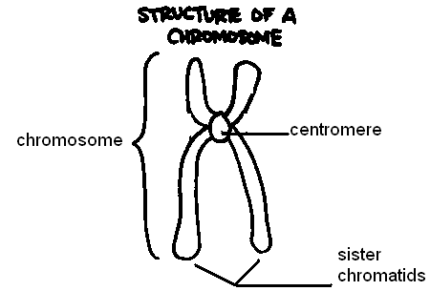

Spindle fibers | microtubule proteins connecting the centromeres to centrioles during mitosis
Centrioles | structures that produce spindle fibers

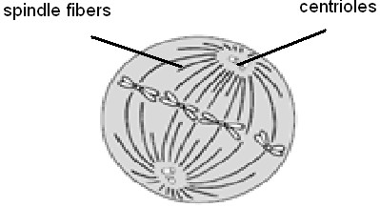

Name: _____________________________________________ Date: __________________ Period: _________________

Unit 5: Cellular Reproduction-Lesson 3
Mitosis Vocabulary

Vocabulary Term | Definition
__________________________________ | relaxed, uncoiled form of DNA in the nucleus
Chromosome
_________________________________ | identical strands of DNA connected by a centromere
Centromeres

_____________________________________ | microtubule proteins connecting the centromeres to centrioles during mitosis
Centrioles

Matching:
- _______ Chromatin

- _______ Chromosomes

- _______ Sister chromatids

- _______ Centromere

- _______ Spindle fibers

- _______ Centrioles
- Microtubule proteins that connect to the centromeres of a chromosome during mitosis
- The relaxed, uncoiled form of DNA in the nucleus
- Structures that produce spindle fibers at the beginning of mitosis
- Tightly coiled strands of DNA and proteins
- Identical strands of DNA connected by a centromere
- The structure that connects sister chromatids after DNA replication

Partner Practice:
- Label the chromosome, sister chromatids and centromere on the diagram below
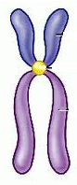
- Label the centromere, sister chromatids, spindle fibers, and centriole on the diagram below.
