Prophase | Metaphase
Anaphase | Telophase
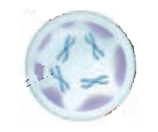 | 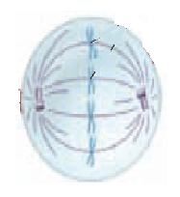
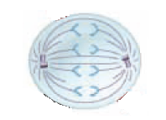 | 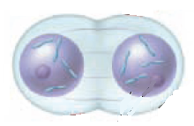
During this phase of mitosis, spindle fibers attach the centromeres to the centrioles, and chromosomes line up along the middle of the cell. | During this phase of mitosis, chromatin condenses into chromosomes. The nuclear membrane disintegrates and spindle fibers form.
During this phase of mitosis, sister chromatids are pulled apart as the spindle fibers shorten. The sister chromatids are pulled to opposite ends of the cell. | During this phase of mitosis, chromosomes relax into chromatin. A nuclear membrane reforms around the chromatin at each end of the cell.

