Partner Names:
Date:
Period:
Jay-Z + Beyoncé = ??

1. Define traits:_________________________________________________________________________
Beyoncé

Skin tone:
Hair type:
Height:
Build:
Eye shape (round, almond, etc.):
Eye color:
Face shape (round, oval, square):
Nose (small, big, etc.):

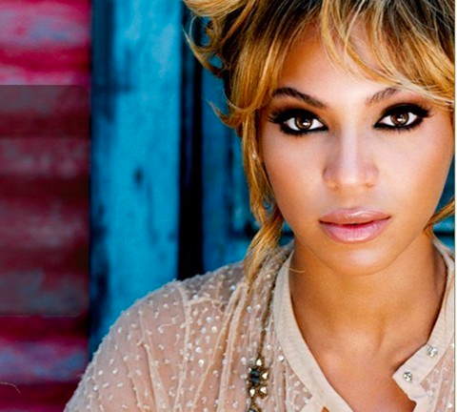
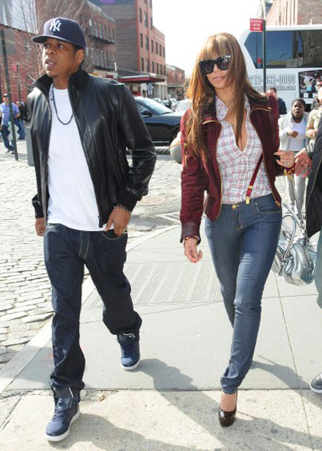
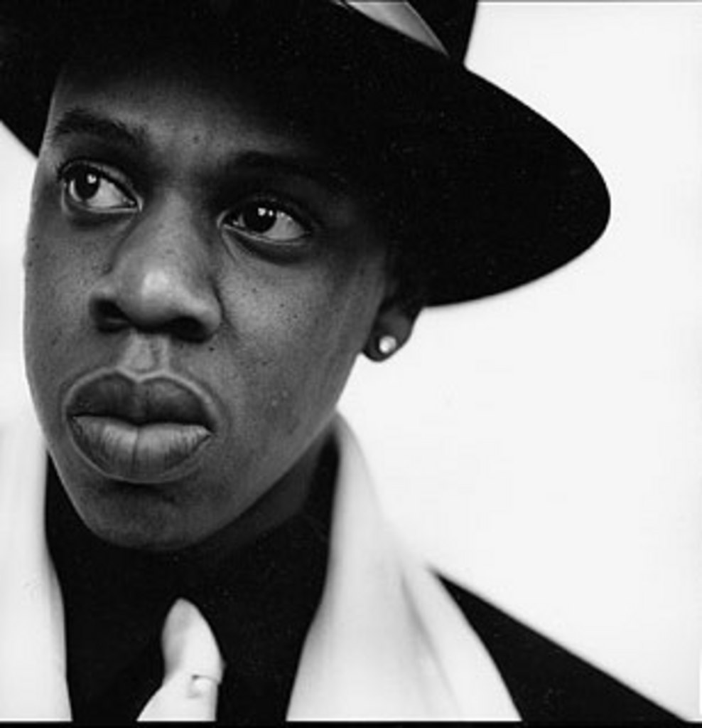
Jay-Z
Skin tone:
Hair type:
Height:
Build:
Eye shape (round, almond, etc.):
Eye color:
Face shape (round, oval, square):
Nose (small, big, etc.):

Baby Jay-oncé

Baby’s First Picture…

Skin tone:
Hair type:
Height:
Build:
Eye shape (round, almond, etc.):
Eye color:
Face shape (round, oval, square):
Nose (small, big, etc.):

