Name: ____________________________________________ Date: __________________ Period: _________________

Unit 4: Cellular Energy-Lesson 8
Cellular Respiration Review Sheet

- Write the balanced equation for cellular respiration below:

______________________________________________________________________________________

- List the reactants and products of cellular respiration.
Reactants Products

- List the three stages of cellular respiration in order:

- How many ATP are produced in each of the three stages?
  - Glycolysis= _____________________
  - Krebs cycle= ____________________
  - Electron transport chain= ___________________

- Complete the chart below with information about anaerobic and aerobic respiration.

 | Anaerobic Respiration | Aerobic Respiration
Does this type of respiration require oxygen?
Which of the three stages is/are this type of respiration?
In what part of the cell does this type of respiration occur?

- Some organisms produce energy in oxygen-free (no oxygen) environments. What process do they use—anaerobic or aerobic respiration? ________________________________________________________How many ATP are produced? __________

- What process follows glycolysis when oxygen is not present? _________________________________________ What is produced during this process that can cause a burning feeling in muscles? _________________________

- Complete the concept map below using the word bank.
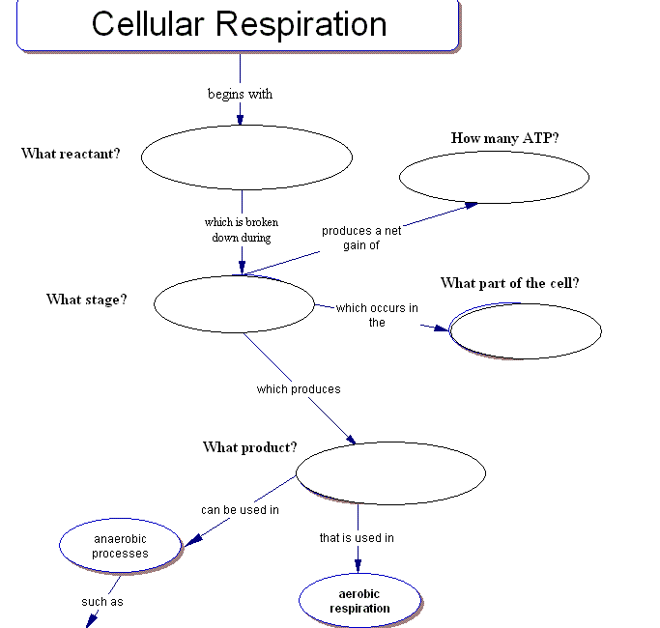
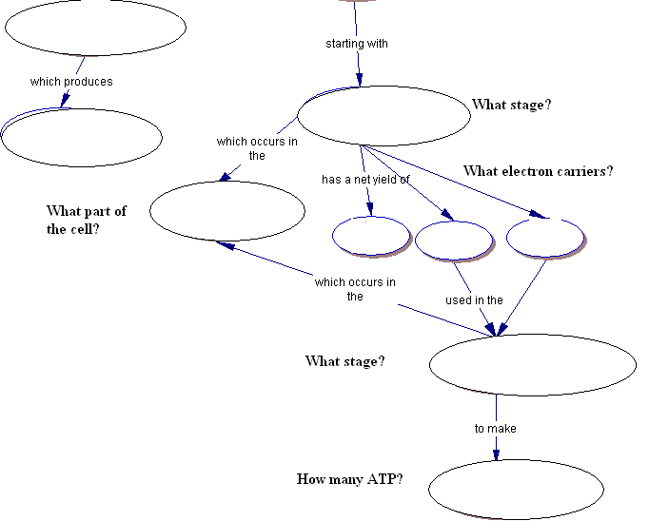

Word Bank (each word only used once)

2 ATP 2 ATP 32 ATP 8 NADH 2 FADH₂ Electron transport chain Mitochondria

Cytoplasm Fermentation Glycolysis Glucose Pyruvate Lactic acid Krebs Cycle

