DNA =

1. A ____________ is a coiled piece of DNA
2. DNA (Deoxyribonucleic acid) controls the production of _________.
3. _________ are the building blocks of an organism. These proteins determine how we look since they make up our skin, hair, and parts of individual cells.
4. It is the ____________ of DNA which determines what proteins are made.
5. DNA is made up of ________, which code for a particular protein
6. These different proteins code for _________

______ _____ _____ ___ _______

7. DNA is in the shape of a _____________ (It looks like a twisted ladder)
8. The backbone of the double helix ladder are made of _______ and __________, or nucleotides.

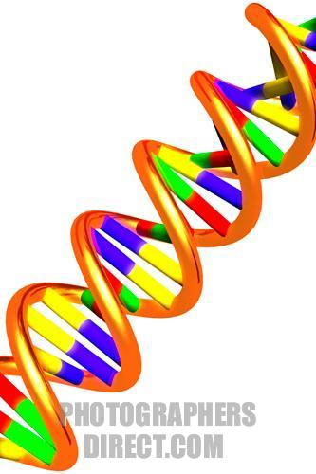

- Nucleotides consist of:

Copy the picture of a nucleotide

9. The rungs of the ladder are made of ______
10. There are ______ bases
1.
2.
3.
4.
11. A pyramidine is:

- The two bases that are pyramidines are:
12. A purine is:
- The two bases that are purines are:

13. _________ and _______ ALWAYS pair together
________ and ________ ALWAYS pair together

Practice: DNA Structure
Directions: Answer the following questions in complete sentences.
- What does DNA stand for?
- How are traits, genes, DNA, and chromosomes all related?
- What are the three parts of a nucleotide?
- What are the two categories of nitrogen bases?
- What are the two purines?
- What are the two pyrimidines?
- What is the backbone of DNA made up of?
- What type of bond holds nitrogen bases together?
- Adenine bases bond to what other nitrogen base?
- Thymine bases bond to what other nitrogen base?
- Guanine bases bond to what other nitrogen base?
- Cytosine bases bond to what other nitrogen base?
- Sugars and phosphate groups make up what part of DNA?
- Draw a nucleotide and label the three parts.
- Draw a DNA strand with one strand of nitrogen bases in this order A, C, G, C, T, G, G, T. Next to that strand draw the other strand, making sure that the correct nitrogen bases are opposite.

